**Hazard Assessment Template**

A **hazard assessment** is the process that supervisors and workers use to identify and control workplace hazards.

Workers and supervisors should complete the hazard assessment together before beginning a new task, working at a new job site, or if the work environment changes because of the season, new equipment, or new procedures.

* **Hazard:** A situation, thing, or condition that may cause an injury, illness, or damage to equipment.
* **Hazard Control:** The action workers and employers take to eliminate or reduce the chance that a hazard will cause harm at the workplace.

|  |  |  |  |  |  |
| --- | --- | --- | --- | --- | --- |
| **Date** |  | | **Worksite** |  | |
| **Task/Job** |  | | | | |
| **Step 1: Identify the Hazard** Write down anything you spot that may be dangerous, or situations that could cause harm to someone. | | | **Step 2: Control the Hazard**  Talk about the best way(s) to remove or reduce the chance of harm.  (***See next page for more on Hazard Controls***) | | |
|  | | |  | | |
|  | | |  | | |
|  | | |  | | |
|  | | |  | | |
|  | | |  | | |
|  | | |  | | |
|  | | |  | | |
| **Step 3: Confirm Assessment** | | **Are all hazards controlled?**  🞎 **Yes.** Share the information with your team.  🞎 **No.** Contact your supervisor to discuss the task. | | | |
| **Step 4: Workers and Supervisor sign the assessment** Supervisor and all workers involved in the assessment should sign below. | | | | | |
| **Supervisor Name** | | | **Signature** | | **Date** |
|  | | |  | |  |
| **Worker Name(s)** | | | **Signature(s)** | | **Date** |
|  | | |  | |  |
|  | | |  | |  |
|  | | |  | |  |
|  | | |  | |  |

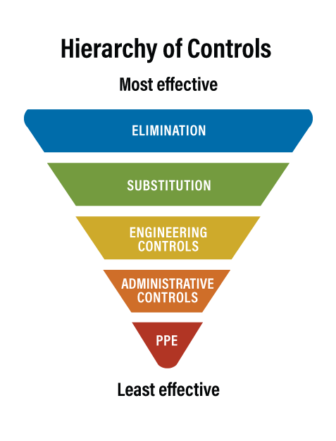**Hierarchy of Controls**

The hierarchy of controls is a step-by-step method to eliminate or reduce hazards in the workplace.

**Always start at the top of the inverted pyramid**. These are the best, most effective methods for controlling hazards and supervisors and workers should consider them first.   
  
For example, if supervisors and workers cannot eliminate a hazard, they should apply substitution, then engineering, and then administrative controls. Workers and supervisors should identify as many controls as they need to adequately protect workers from the hazard. If a hazard cannot be eliminated, a combination of controls will be needed to keep workers safe.

|  |  |
| --- | --- |
| **Eliminate the Hazard** | Eliminating or removing a hazard is the most effective control. Simply remove the hazard, unsafe task, condition, equipment, or chemical from the worksite. |
| **Substitute for Something Safer** | Switch a dangerous work method, substance, tool, or piece of equipment for a safer option.   **Examples:** Assign a worker who has been properly trained instead of an untrained worker, use water-based paint instead of solvent-based paint, or switch to safety goggles instead of safety glasses. |
| **Engineer a Control** | Engineering controls are methods built into the *design* of a worksite, equipment, or process to minimize, eliminate, or contain the hazard. An engineering control will prevent the hazard from contacting the worker.   **Examples:** Build guards, barriers to prevent access to dangerous conditions, install mechanical lifting devices, paint with a brush instead of spray painting, or increase ventilation for certain jobs. |
| **Administrative Controls** | These controls will provide an acceptable way to work around a hazard by ensuring workers conduct jobs and tasks in a way that minimizes the hazard’s impact on workers or equipment. Administrative controls are usually implemented with other control measures.   **Examples:** Providing training for using and inspecting PPE, or safe operating procedures for equipment. |
| **Personal Protective Equipment (PPE)** | PPE is a critical part of a health and safety program and refers to anything workers wear to help protect them from a hazard. Workers must wear PPE correctly to limit their exposure to the hazard.   **Examples of PPE:** Safety goggles for eye protection, gloves for reducing vibration, ear plugs for loud environments, or steel-toed boots in construction areas. |

*For more information, visit CCOHS online:* [*www.ccohs.ca/oshanswers/hsprograms/hazard/hierarchy_controls.html*](http://www.ccohs.ca/oshanswers/hsprograms/hazard/hierarchy_controls.html)